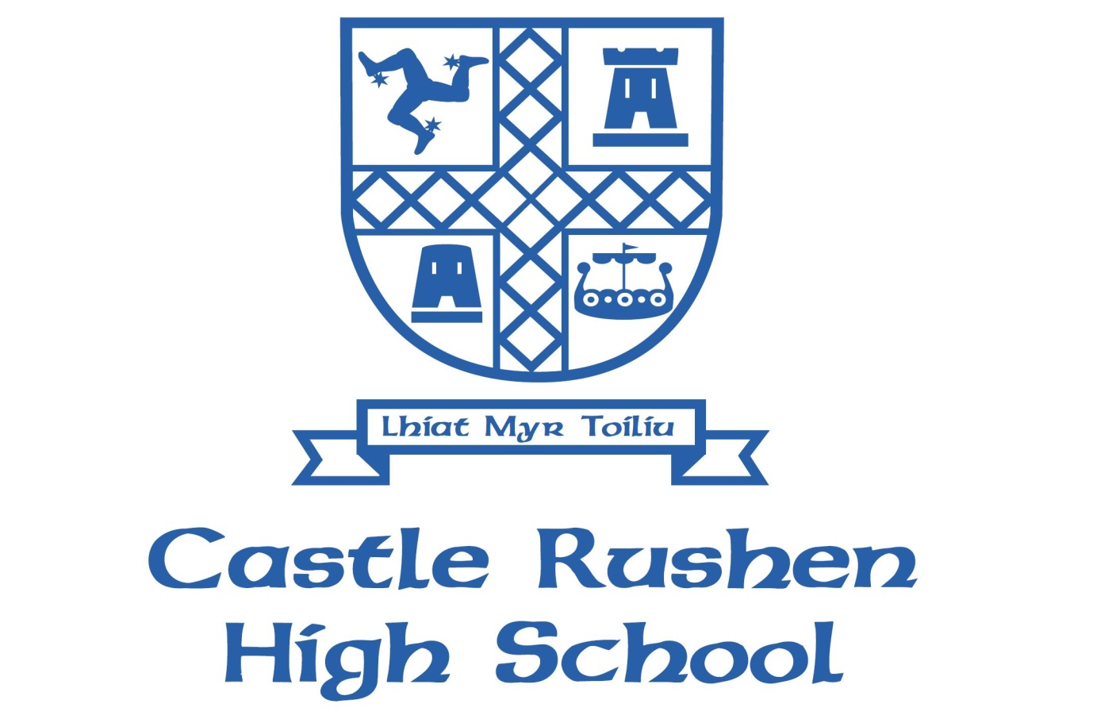
Sex & Relationship Education (SRE) Policy

Contents
The Consultation Process 3
What Is Sex and Relationship Education? 3
Main Aspects of Curriculum 3
Organisation and Content of Sex & Relationship Education 4
Inclusion 4
Right of Withdrawal of Students from Sex & Relationship Education 5
Confidentiality, Controversial and Sensitive Issues 5
Monitoring and Evaluation of Sex and Relationship Education 5

Introduction

Castle Rushen High School is committed to creating and sustaining a safe, positive and inclusive environment for all pupils, staff and parents/carers. Castle Rushen further aims to promote children’s health and wellbeing.

This policy was developed in response to IOM DoEC SRE Policy Statement SRE Guidance, Sex and Relationship Education Guidance DfES 2000. This policy makes reference to the CRHS Drugs Policy, E-Safety Policy, Safeguarding/Child Protection Policy, Dept of Health guidance on under age sex and DEC confidentiality Policy.

The Consultation Process
- Review of SRE curriculum content with staff and pupils (Year 7)
- Consultation with school governors
- Consultation with Key Stage Leaders

As this is currently a working document consultation is still to take place with school council, parents/carers and the wider staff.

What Is Sex and Relationship Education?
SRE is lifelong learning about physical, sexual, moral and emotional development. It is about understanding the importance of stable and valued relationships, respect, love and care, for family life. Teaching this curriculum involves self and peer reflection, independent learning, building relationships of trust and respect in a classroom environment through role play and directed discussion that focus on forming positive beliefs, values and attitudes. At CRHS all Key Stages have directed time for SRE lessons

Main Aspects of Curriculum
The aim of SRE is to provide balanced factual information about human reproduction, together with consideration of the broader emotional, ethical, religious, and moral dimensions of sexual health.

Sex and Relationship Education in this school has three main elements:

- Attitudes and Values
  - learning the importance of values, individual conscience and moral choices;
  - learning the value of family life, stable and loving relationships, and marriage;
  - learning the value of respect, love and care;
  - exploring, considering and understanding moral dilemmas;
  - developing critical thinking as part of decision-making
  - challenging myths, misconceptions and false assumptions about normal behaviour.

- Personal and Social Skills
  - learning to manage emotions and relationships confidently and sensitively;
  - developing self-respect and empathy for others;
  - learning to make choices with an absence of prejudice;
  - developing an appreciation of the consequences of choices made;
  - managing conflict;
  - empower students with the skills to be able to avoid inappropriate pressures or advances (both as exploited or exploiter)
  - understanding the importance of positive and safe online relationships

- Knowledge and Understanding
  - learning and understanding physical development at appropriate stages;
  - understanding human sexuality, reproduction, sexual health, emotions and relationships;
  - learning about contraception and the range of local and national sexual health advice, contraception and support services;
  - the avoidance of unplanned pregnancy.
  - Drug and alcohol misuse

Organisation and Content of Sex & Relationship Education
CRHS specifically delivers Sex and Relationship Education through its PSHE Programme, RE and Science lessons at KS3, KS4 and KS5.

Much of the Sex and Relationship Education at CRHS takes place within PSHE lessons. At KS3 tutors generally deliver the PSHE Curriculum with support from professionals where appropriate. At KS4 and KS5, Lifeskills lessons are delivered by trained teaching staff and appropriate outside organisations.

SRE lessons are set within the wider context of the Lifeskills curriculum and focus more on the emotional aspects of development and relationships, although the physical aspects of puberty and reproduction are also included. The Science National Curriculum is delivered by staff in the science department. These lessons are more concerned with the physical aspects of development and reproduction, although the importance of relationships is not forgotten.

ThePSHE Programme and Science National Curriculum is taught in Year 7.

Any SRE lesson may consider questions or issues that some students will find sensitive. Before embarking on these lessons ground rules are established which prohibit inappropriate personal information being requested or disclosed by those taking part in the lesson. When students ask questions, we aim to answer them honestly, within the ground rules established at the start of the sessions. When it is felt that answering a specific question would involve information at a level inappropriate to the development of the rest of the students, the question may be dealt with individually at another time.

Assessment is carried out at the end of every module and involves teacher, pupil and peer assessment of knowledge and understanding, interpersonal skills, and attitudes. This is done through student surveys.

Inclusion
Ethnic and Cultural Groups
We intend our policy to be sensitive to the needs of different ethnic groups. For some young people it is not culturally appropriate for them to be taught particular items in mixed groups. We will respond to parental requests and concerns.

Students with Special Needs
We will ensure that all young people receive sex and relationship education, and we will offer provision appropriate to the particular needs of all our students, taking specialist advice where necessary.

Sexual Identity and Sexual Orientation
We aim to deal sensitively and honesty with issues of sexual orientation, answer appropriate question and offer support. Young people, whatever their developing sexuality need to feel that sex and relationship education is relevant to them. All staff delivering SRE lessons have been supported on how to adapt language and provide guidance on where to seek support for sexual identity and orientation.

Right of Withdrawal of Students from Sex & Relationship Education
Some parents prefer to take the responsibility for aspects of this element of education. They have the right to withdraw their children from all or part of the sex and relationship education except for those parts included in the statutory National Curriculum (i.e. in Science lessons).

Parents are encouraged to discuss their decisions with staff at the earliest opportunity initially in writing to the head teacher. Parents are welcome to review any SRE resources the school uses.

Confidentiality, Controversial and Sensitive Issues
Teachers cannot offer unconditional confidentiality. At CRHS teachers will disclose any information they feel may put a child at risk to the designated child protection officer. In any case where child protection procedures are followed, the teacher will ensure that the young person understands that if confidentiality has to be broken, they will be informed first.

In a case where a teacher learns from an under 16 years old that they are having or contemplating sexual intercourse:
- the young person will be persuaded, wherever possible, to talk to parent/carer and if necessary to seek medical advice.
- child protection issues will be considered, and referred if necessary to the teacher responsible for Child Protection under the school's procedures
- the young person will be properly counselled about contraception, including precise information about where young people can access contraception and advice services. This will be done through the school nurse and EFA/Listening service

Health professionals in school are bound by their codes of conduct in a one-to-one situation with an individual student, but in a classroom situation they must follow the DEC’s confidentiality policy.

Monitoring and Evaluation of Sex and Relationship Education
It is the responsibility of Leadership Team to oversee and organise the monitoring and evaluation of the Lifeskills curriculum.

The Lifeskills curriculum is treated as a stand-alone subject and is monitored in line with all other subjects through lesson observations and student feedback survey.

