

**Year 12 Geography**

**Transition Booklet**

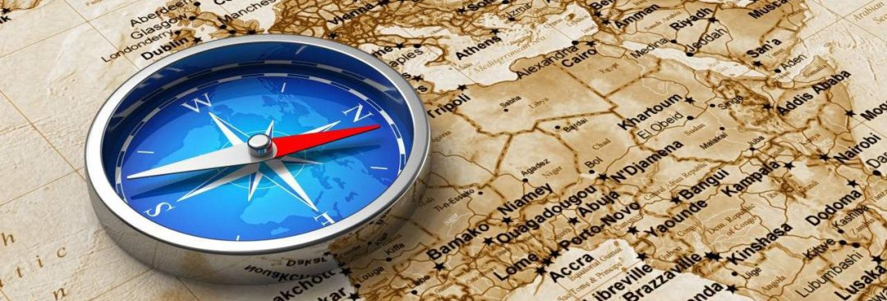



**Recommended reading over the summer holidays…**

# https://images-na.ssl-images-amazon.com/images/I/51G4tyBGJoL._SX323_BO1,204,203,200_.jpg

# Prisoners of Geography: Ten Maps That Tell You Everything You Need to Know About Global Politics.

# Available from Amazon:

# Kindle Edition: £2.09

# Paperback: £5.99



**AS Geography Specification**

**Paper 1: Core Geography**

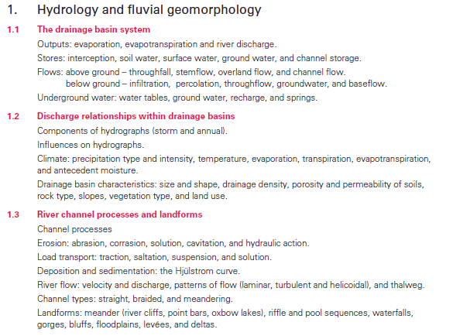**The Physical Core**

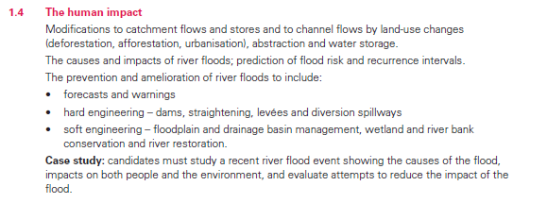



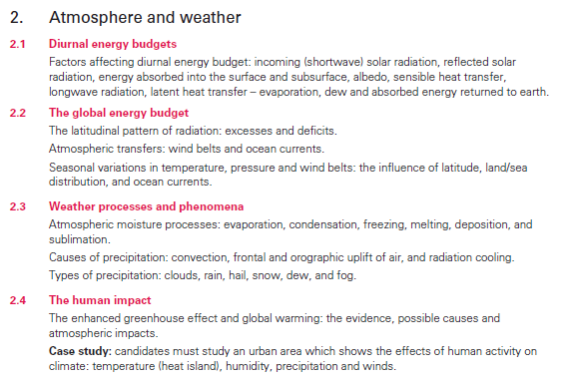

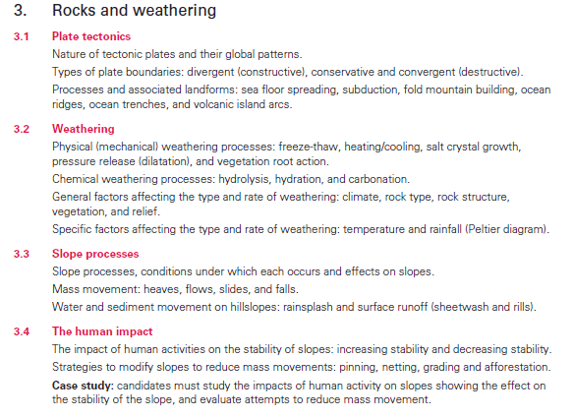



**Paper 1: Core Geography**

**Human Core**

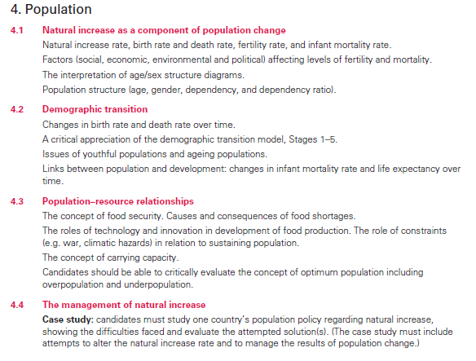

****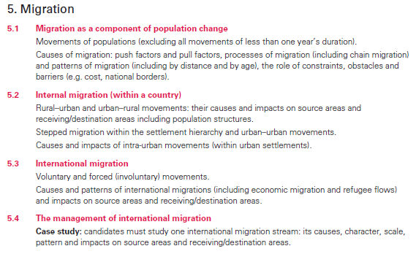

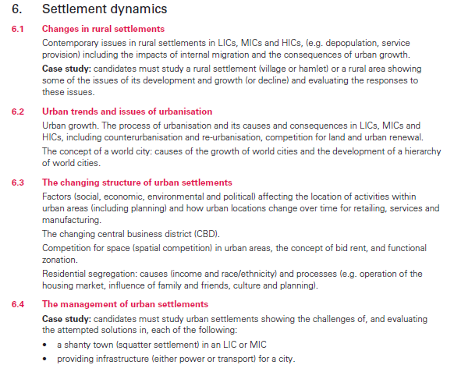

**Further information and examples of examination papers can be found at the following website:**

<http://www.cie.org.uk/programmes-and-qualifications/cambridge-international-as-and-a-level-geography-9696/>

**AS exam at the end of Year 12.**



**Human Core: Population**

**What you need to know:**

* **Birth rate** (or Crude Birth Rate [CBR]: is the number of live births per thousand people, within a given population, per year. This is expressed as e.g. 13/1000 or 13‰ (the UK CBR for 2010).
* **Death rate** (or Crude Death rate [CDR]) is the number of deaths per thousand people, within a given population, per year. This is expressed as e.g. 9/1000 or 9‰ (the UK CDR for 2010).
* **Fertility rate**: Thisis the number of live births per thousand women aged 15–49 per year. The total fertility rate is the average number of children each woman in a population will have. In the UK in 2009 it was 1.94 children per woman.
* **Infant mortality rate:** This is the number of infant deaths (in the first year of life) compared to the number of live births in one year. In the UK it is 5 per thousand births.
* **Life expectancy:** This can be expressed in two ways
  + Life expectancy at birth: the age that someone is expected to live to from birth. The disadvantage of this is that high infant mortality will pull this figure down and make it unrealistic for people who reach e.g. the age of five. Male life expectancy for the UK is 77.7 years,
  + Life expectancy at a given age: this is a measure of how many years someone has left at any given age. This overcomes the disadvantages of the simple life expectancy.
* **Migration rate:** this is a measure of the balance between immigration and emigration. Net migration in the UK was +163,000 in 2007, with 590,000 immigrants and 427,000 emigrants.
* **Population density:** This is expressed at the number of people living in a country/region divided by the area and expressed a people/km². It is difficult to link this to economic development.

**Now answer the following questions**

1. **Outline the differences between birth rate and fertility rate.**

______________________________________________________________________________________________________________________________________________________________________________________________________________________________________________ 4 marks

1. **Outline the factors that lead to changing population density.**

****_______________________________________________________________________________________________________________________________________________________________________________________________________________________________________________________________________________________________________________________________ 4 marks

1. **Study figure 1. It gives information on infant mortality rate and GDP per capita for 10 countries in 2003.**

**Figure 1**

|  |  |  |
| --- | --- | --- |
| Country | Infant mortality rate (per 1000 live births per year) | GDP per capita  (US$) |
| Sierra Leone | 146.9 | 500 |
| Niger | 123.6 | 800 |
| Kenya | 63.4 | 1000 |
| Haiti | 76.0 | 1600 |
| Brazil | 31.7 | 7600 |
| Malaysia | 19 | 9000 |
| South Africa | 60.84 | 10700 |
| Saudi Arabia | 47.9 | 11800 |
| Estonia | 12.0 | 12300 |
| Luxembourg | 4.7 | 55100 |

**Comment on how useful infant mortality rate is as an indicator of development.**

____________________________________________________________________________________________________________________________________________________________________________________________________________________________________________________________________________________________________________________________________________________________________________________________________________________________________________________________________________________________________ 5 marks



**Physical Core:** **Hydrology and geomorphology**

The drainage basin hydrological cycle: the water balance.

**Figure 1 The drainage basin hydrological cycle**

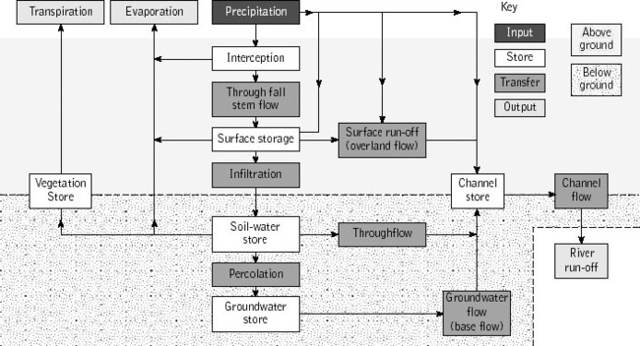

[From: <http://science.jrank.org/article_images/science.jrank.org/hydrological-cycle.1.jpg>]

* You need to understand how changes in local conditions can change the way that water flows through the system. E.g.

1. Deciduous forests intercept more precipitation in summer than winter because they shed their leaves in winter.
2. Vegetation stores, uses and transpires much more water in spring and summer than it does in winter.
3. Urban areas have many more impermeable surfaces than rural areas and so infiltration is low and over-land flow is much higher.

* You must understand the concept of the **water balance**. The drainage basin hydrological cycle is an open system. Although the relationship between the inputs and outputs can be very complex, it can be summed up by the equation:

*P* = *Q* + *E* +/- *S* where:

*P* is precipitation

*Q* is runoff (measured in m3s-1or CUMECS)

*E* is evapotranspiration

****Δ*S* is the change in storage (in surface, soil, vegetation or the bedrock).

**What you need to know:**

* How water reaches a channel in a drainage basin. This can be summed up in figure 2



* Overland flow, groundwater flow, throughflow and direct precipitation vary according to the environmental conditions.
* The speeds of these transfers differ. Direct precipitation reaches the river first. This is followed by overland flow and then the much slower throughflow and groundwater flows.  
    
  Once this is understood then you have to:
* 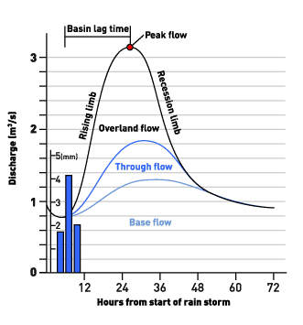Be able to describe, explain the shape of and sketch a storm hydrograph. This is summed up in figure 3.

[From <http://www.bbc.co.uk/scotland/education/int/geog/rivers/images/hydrographs/hydro1.gif>]

* ****You must be able to describe and explain how the shape of a storm hydrograph may vary because of variations in the drainage basin hydrological cycle. E.g.

1. The storm hydrograph for an urban area is more flashy than one for a rural area.
2. The storm hydrograph for a river in deciduous woodland is flashier in winter than summer.
3. The intensity of precipitation affects the steepness of the rising limb.
4. **Describe the various ways in which water reaches a river channel.**

_______________________________________________________________________________________________________________________________________________________________________________________________________________________________________________________________________________________________________________________________________________________________________________________________________________________________________________________________________________________________________________________________________________________________________________________________________________________________________________ [4 marks]

1. **Define the term ‘interception’ *(this could be: infiltration, percolation, throughflow, groundwater flow etc)***

_______________________________________________________________________________________________________________________________________________________________________________________________________________________________________________________________________________________________________________________ [2 marks]

1. **Explain how a drainage basin dominated by deciduous forest may affect the discharge of a river. *(this could be: dominated by permeable rock or impermeable urban surfaces etc)***

****____________________________________________________________________________________________________________________________________________________________________________________________________________________________________________________________________________________________________________________________________________________________________________________________________________________________________________________________________________________________________________________________________________________________________________________________________________________________________________________________________________________________________________________________________________________________________________________________________________ [5 marks]

**Population glossary**

**Learn the key terms**

**Crude Birth rate**

Thisis the number of live births per thousand people per year.

**Crude Death rate**

This is the number of deaths per thousand people per year.

**Fertility rate**

This is the number of live births per thousand women aged 15-49 per year.

**Infant mortality rate**

This is the number of children under the age of one who die per thousand live births per year.

**Natural increase rate**

This is the crude birth rate *minus* crude death rate.

**Doubling time**

Refers to the expected time taken for a country’s population to double.

**Life expectancy**

This is the average age to which a person is expected to live, at birth.

**Migration**

This refers to people moving to a different location on a permanent basis.

**Population density**

This is the number of people living per unit of land.



**Demographic Transition Model** (DTM)

The model describes the change in the population of a country over time (or as a country develops economically).

**Juvenility Index**

This is the total population aged 0-19 divided by population over 20.

**Dependency ratio**

It is the ratio of dependents to workers in a population.

**A young population**

This has a large number of younger people in proportion to the working population.

**An ageing population**

This has a large number of older people in proportion to the working population.

**Overpopulation**

This is where the population is too large for the resources available.

**Under population**

This exists where there are not enough people living in an area or country to utilise resources efficiently.

**Optimum population**

This is where the resources available can be developed efficiently to satisfy the needs of the current population and provide the highest standard of living for a given level of technology.

**  
Neo Malthusians**

Named after the pessimistic views of Malthus, they are theorists who predict that there will be a sudden decline in total population due to over-use of resources.

**Agenda 21**

Thisrefers to the UN sustainable development programme but applied at a local level.

|  |  |
| --- | --- |
| Abrasion | The scraping, scouring, rubbing, grinding and drilling action of materials being moved by a river |
| Attrition | The collision of one piece of a river’s load with another, breaking off bits of rock in the process. This has the effect of making the load rounder and smaller. |
| Base level | The lowest limit to which erosion can take place, usually sea level. |
| Braiding | This occurs when a heavily loaded river rapidly loses energy and rocks are deposited mid-channel. |
| Channel cross profile | The view of a river channel from one side of the channel to the other. |
| Cumec | The unit of discharge measured in m3s-1 |
| Deforestation | The deliberate clearance of forest by cutting or burning |
| Deposition | The laying down of solid material, such as silt, on the river bed or floodplain. |
| Drainage basin | The area of land drained by a river and its tributaries |
| Drainage basin hydrological cycle | An open system with inputs, outputs, transfers and stores that maps the movement of water through a drainage basin. |
| Drilling | A form of abrasion where a pebble trapped in a hollow on a stream bed is rotated by the moving water so that it wears away the bedrock in a circular fashion. |
| Efficiency | The ratio of the cross-sectional area of a river and its wetted perimeter. It is expressed as the hydraulic radius. |
| Erosion | The wearing away of the land surface by rocks carried in a river. |
| Evapotranspiration | The total amount of water leaving a vegetated surface by the joint processes of evaporation and transpiration. |
| Graded profile | A theoretical form of river long profile that exists when there is a balance between the rate of erosion and the rate of deposition. Typically it is steep near the source and reduces in gradient towards the base level. |
| Groundwater | Water which collects underground in pore spaces in rock |
| Groundwater flow | The movement of groundwater. This is the slowest transfer of water within the drainage basin. It provides water for the river during drought. |
| Hard engineering | A series of management strategies where there is controlled disruption of natural processes by using man-made structures. |
| Hjulstrom’s curve | A graph that shows the relationship between the velocity of a river and the size of particles that can be eroded, transported and deposited. |
| Hydraulic action | An erosion process where the banks and bed of the river a eroded by the moving water alone. |
| Hydraulic radius | A measurement of the efficiency of a river; the ratio of the cross-sectional area of a river and its wetted perimeter. |
| Infiltration | The movement of water from the surface downwards into the soil. |
| Interception | The process by which precipitation is prevented from reaching the soil by leaves and branches of trees as well as by herbaceous plants and grasses. |
| Kinetic energy | The energy of a moving mass. It is a function of mass and velocity |
| Long profile | A diagram that shows the changes in the altitude of a river’s course as it goes from source to mouth. |
| Overland flow | The rapid movement of water over saturated or impermeable land. |
| Percolation | The downward movement of water from soil to the rock below or within rock. |
| Potential energy | The energy stored in a mass as a result of its position in a force field (in this case gravity). |
| Recurrence interval | The frequency with which a flood of given magnitude is likely to occur. |
| Rejuvenation | An increase in the energy of a river as a result of a fall in base level or uplift of land. |
| Roughness | A measurement of the frictional drag of a river bed on the moving water. It is calculated using the Mannings N formula. |
| Runoff | All the water that flows out of a drainage basin |
| Saltation | A form of transportation where particles bounce along the river bed. |
| Soft engineering | Ecologically sensitive management solutions to river erosion and flooding e.g. afforestation or land use zoning. |
| Solution | A form of erosion where the river water dissolves soluble bedrock. |
| Store | A part of the hydrological cycle where water stops moving. This can be either temporary or permanent. |
| Storm hydrograph | A graph of river discharge in cumecs over the period of time from the onset of a rainstorm to when the river returns to its normal flow. |
| Suspension | The transportation process where small material is carried in the body of a river. |
| Thalweg | The part of the river that has maximum velocity and depth. |
| Throughfall/stemflow | The water that drips off leaves or travels down the trunk of a tree during rainfall. |
| Throughflow | The water that moves down-slope through soil. |
| Traction | The rolling of river bedload along a river channel |
| Transportation | The movement of eroded particles from their origin to the place they are deposited. |
| Valley cross profile | The view of a river valley from one side of the channel to the other. |
| Wetted perimeter | The total length of a river channel in cross-section which is in contact with the water. |