ICT |  |  |  |  |  | 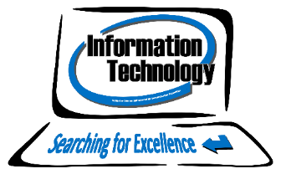
Exam Board: | Cambridge International | Syllabus Code: |  |  | 0417
Course outline:
The Information Communication Technology syllabus encourages students to develop lifelong skills, which will be useful to them in their work across the curriculum and prepare them for future employment. Students will develop an understanding of the implications of technology in society, including social, economic and ethical uses and awareness of the ways ICT can help in home, learning and work environments.

The syllabus combines theoretical and practical studies focusing on the ability to use common software applications to solve problems, including word processors, spreadsheets, databases, interactive presentation software, web browsers and website design. Learners analyse, design, implement, test and evaluate ICT systems, ensuring that they are fit for purpose.

Course assessment:
The assessment of the Cambridge IGCSE ICT course is all at the end of Year 11 and takes the form of 3 examinations:

Paper | Topic |  | Length | Weighting |  |  | Assessment
1 | Theory |  | 1hr 30 hours minutes | 40% |  |  | External
2 | Document Production, Data Manipulation and Presentations |  | 2 hours 15 minutes | 30% |  |  | External
3 | Data Analysis and Website Authoring |  | 2 hours 15 minutes | 30% |  |  | External
What qualities do I need to take this subject?
Having even a basic understanding of ICT can open up a lot more opportunities in the workplace, whether you’re working in a shop, an office or elsewhere in industry. It is widely known that there is a skills shortage in the ICT sector. Most employers today expect staff to be able to use a computer and, used well, technology is a tool that can empower you and help you succeed, it also looks good on your C.V. So if you want to deepen your knowledge of technology, enjoy practical activities, can problem solve and want to learn new skills in an engaging way then ICT is for you!
What can this course lead to?
Students who have completed this course can move on to Level 3 BTEC Extended Certificate in IT or a range of UCM IT courses. The ability to work with and use ICT correctly is an invaluable transferrable skill in our society, no matter which pathway you may follow in the future. Students who have completed this course can develop lifelong skills in a wide variety of software, which will be useful to them in their work across the curriculum and prepare them for future employment. It is suitable for those wishing to continue onto further IT pathways or into employment.

