Components | Marks | Weighting
1 Listening Exam  1 hour 15 minutes paper based on different musical areas of study. | 70 marks | 40%
2 Performing Coursework  Two prepared performances, one solo and one ensemble performed on any instrument or voice. | 50 marks (25 marks per performance) | 30%
3 Composing Coursework  Two contrasting compositions in any style appropriate to the students musical genre. | 100 marks scaled to 50 marks (25 marks per performance) | 30%
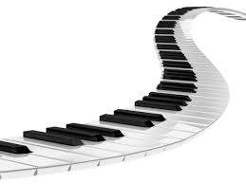
The Cambridge IGCSE course will develop students’ understanding of how music is created through performing, composing, listening and appraising; these elements provide a means through which the students will examine a wide variety of musical traditions. It is a challenging course which will provide an excellent foundation for A level Music. The course is broken down into the following areas:

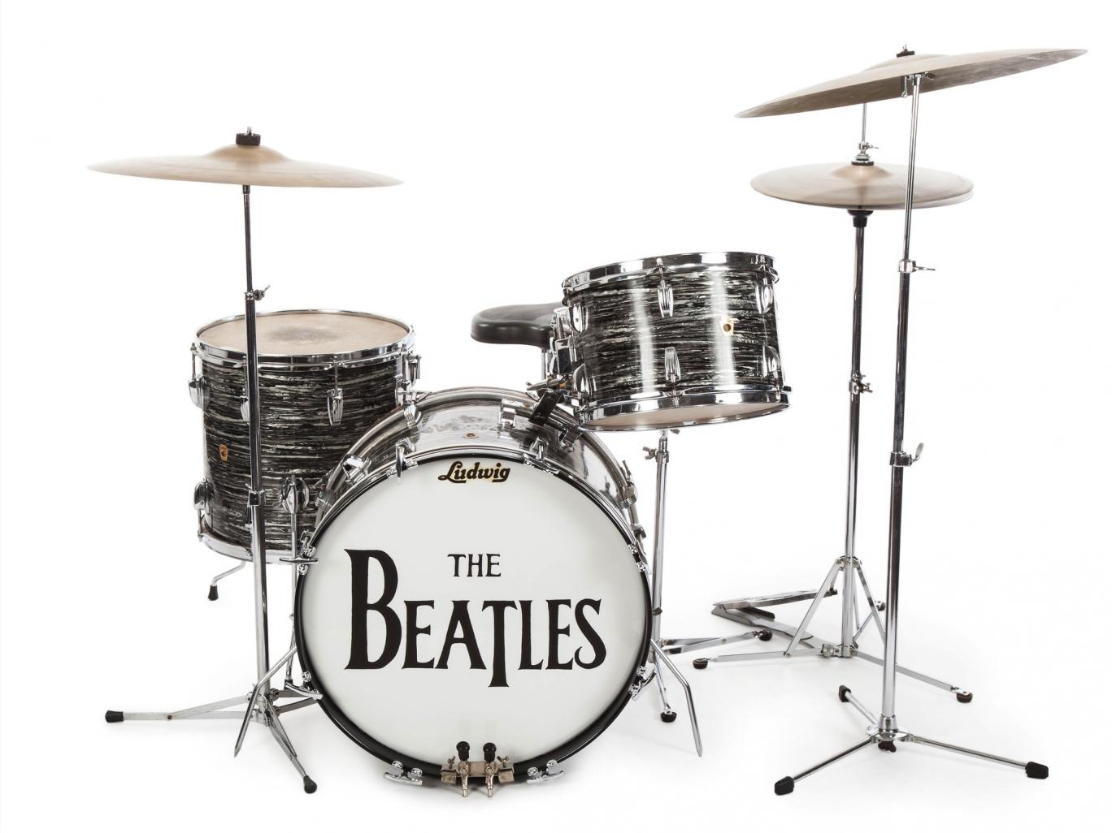
60% of the course is coursework based and 40% is listening. This offers students lots of practical opportunities.

Content of the IGCSE:

Listening - The Listening and Appraising paper is in 5 sections: Unprepared Western Repertoire (features of the Western classical tradition), Unprepared World Music, Skeleton Score (including rhythmic and melodic dictation), World Music – One Prescribed area of Focus and one Western Set Work. Questions will explore key musical features which will have been studied during the course.
Composing- to submit two compositions, either contrasting in character or written for different instruments. Compositional techniques will be a major focus of lessons to build confidence in this area.
Performing- i) One or two short individual performances, which may be on the same or different instruments, and ii) to sing or play in an ensemble with other performers.

